**Experiment No. 8 -Operators in genetic algorithms**

**Aim:-**Apply operators in genetic algorithms on given problem to find a binary string with all ones.

**Tools:** Python 3 language and Jupyter Notebook

**Theory:**

**Genetic Algorithms (GAs)**

Genetic Algorithms are optimization techniques inspired by the principles of natural selection and genetics. They are used to find solutions to complex problems by evolving a population of candidate solutions over successive generations. GAs are particularly useful for problems where traditional optimization methods struggle.

**Key Components of Genetic Algorithms**

1. **Population**: A set of potential solutions (often represented as binary strings or chromosomes) that evolve over time.
2. **Chromosome**: A representation of a solution, typically as a string of bits (0s and 1s).
3. **Fitness Function**: A function that evaluates how close a given solution is to the optimal solution. It quantifies the quality of the solution.

**Genetic Operators:** Genetic operators are crucial for guiding the search process in GAs. The three main types of operators are:

1. **Selection**:
   * The process of selecting individuals from the current population to create the next generation.
   * Common methods include:
     + **Roulette Wheel Selection**: Selects individuals based on their fitness, with higher fitness individuals having a greater chance of being selected. It resembles a roulette wheel where the size of each segment corresponds to the fitness of the candidate solutions.
     + **Tournament Selection**: A group of individuals is chosen randomly, and the one with the highest fitness is selected.
2. **Crossover**:
   * Also known as recombination, crossover combines the genetic information of two parents to produce one or more offspring.
   * **Single-Point Crossover**: A random crossover point is selected on the parent chromosomes, and the genetic material is exchanged at this point to create new offspring.
   * Crossover encourages diversity in the population by mixing traits from different solutions.
3. **Mutation**:
   * A process that introduces random changes to individual chromosomes, helping to maintain genetic diversity within the population.
   * **Bit Flip Mutation**: Each bit in a binary string has a certain probability (mutation rate) of being flipped from 0 to 1 or from 1 to 0.
   * Mutation helps prevent premature convergence to suboptimal solutions by ensuring that new solutions are explored.

**Algorithm Workflow**

1. **Initialization**: Generate an initial population of random solutions.
2. **Evaluation**: Assess the fitness of each individual using the fitness function.
3. **Selection**: Select individuals based on their fitness to serve as parents for the next generation.
4. **Crossover**: Combine pairs of parents to produce offspring.
5. **Mutation**: Apply mutation to the offspring to introduce variability.
6. **Replacement**: Replace the old population with the new one, forming the next generation.
7. **Termination**: Repeat the evaluation, selection, crossover, and mutation steps until a stopping criterion is met (e.g., a solution is found, or a maximum number of generations is reached).

**Applications**

Genetic algorithms are widely used in various fields, including:

* Optimization problems (e.g., scheduling, routing)
* Machine learning (e.g., feature selection, hyperparameter tuning)
* Game development (e.g., evolving game strategies)
* Engineering design (e.g., structural optimization)

**Code:**

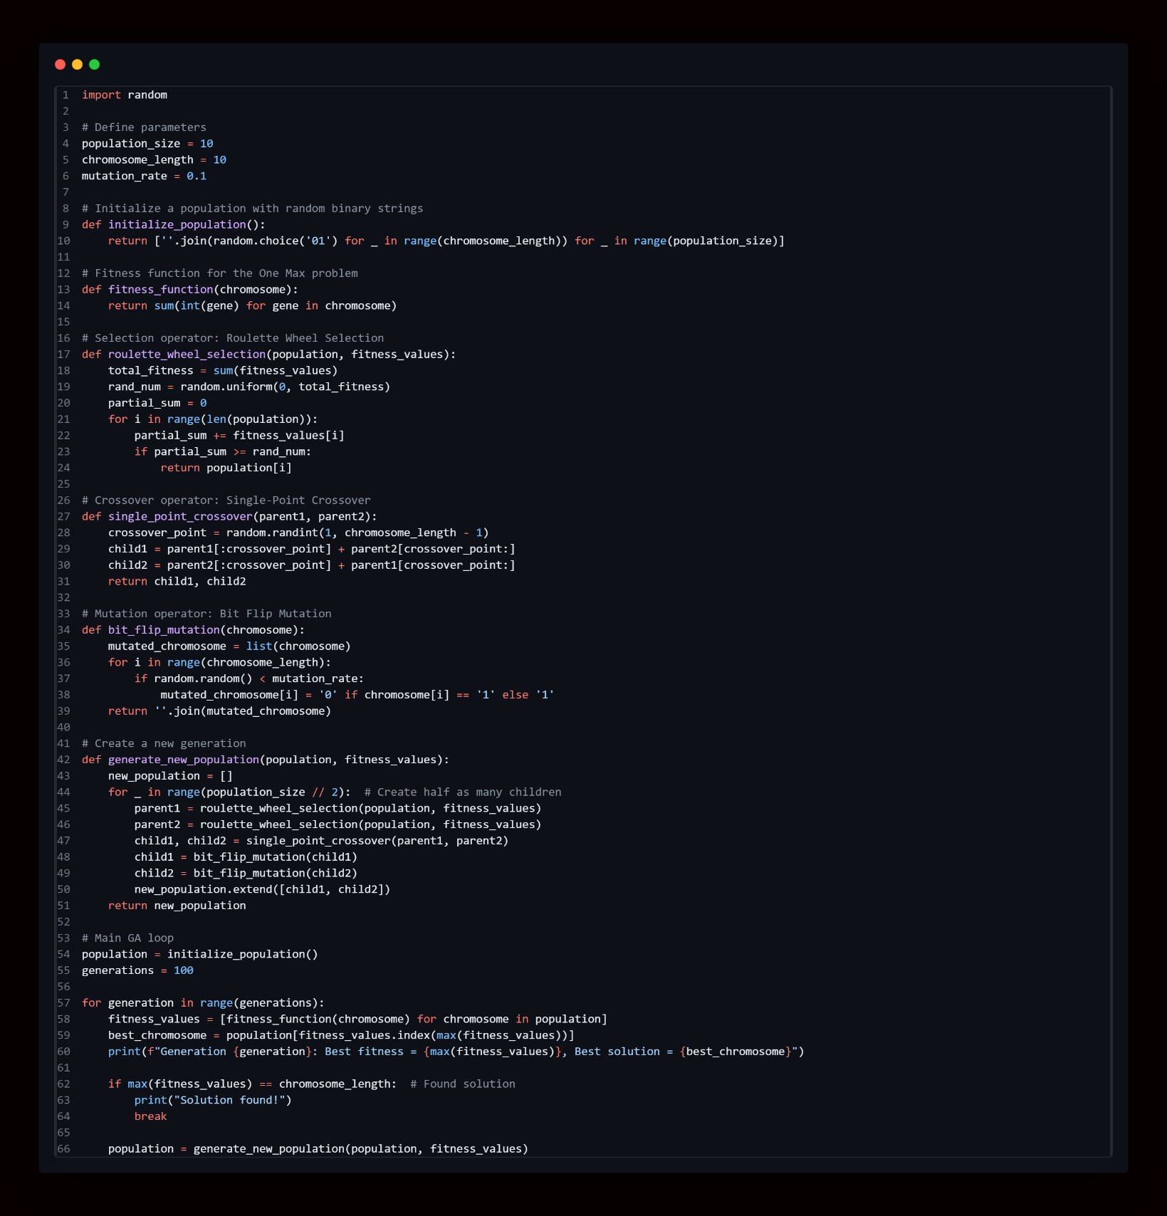

**Output:**

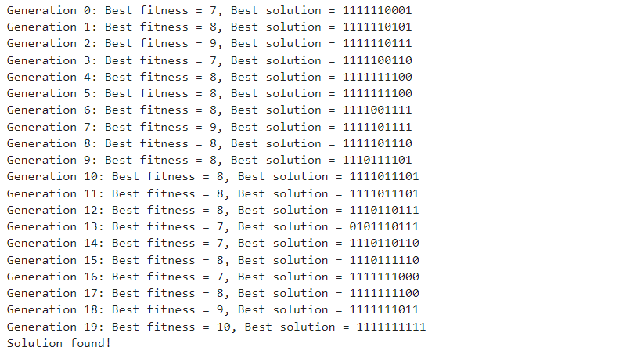

**Conclusion:**

___________________________________________________________________________________________________________________________________________________________________________________________________________________________________________________________________________

**_________________________________________________________________________________________**

|  |  |  |  |  |
| --- | --- | --- | --- | --- |
| **Correction** | **Formative** | **Timely** | **Attendance /** |  |
| **Parameters** | **Assessment** | **completion of** | **Learning** |
|  | **[40%]** | **Practical [ 40%]** | **Attitude** |
|  |  |  | **[20%]** |
| **Marks** |  |  |  |
| **Obtained** |

For Faculty Use: